**Test Case 2 – Single window with overhang that bisects the window height**

*Test Description* : A 1-zone, one story, simple model with exterior shading devices that act as overhangs and exterior light shelves for windows on the south façade. Light shelves are 1” thick and split a single window instance in the BIM along its centerline. This test is designed to ensure that this window should be represented as two windows in gbXML, the one window that is above the overhang, and the other that is below.

This is because the simulation software that consumes this window geometry in many instances requires two windows in order to properly define the solar penetration of this one window instance in the BIM.

*Space Name(s):* This is important because the gbXML validator requires the strings in the test file match the standard file. The name check is case sensitive.

|  |  |  |
| --- | --- | --- |
| Standard File Space Name | Test File Space Name | Verified |
| sp-1-Space |  |  |

*Special Considerations:*

1. The windows should be of openingType =’OperableWindow”
2. Though the tilt and azimuth of the shading devices could be argued as arbitrary, this test will be looking to ensure the azimuth is 0(zero) and tilt is 0(zero) for each of these tests.

*Complexity of the BIM Model:*

1. Simple planar surfaces orthogonal to the project Cartesian reference frame.
2. Single wall thickness throughout the project (in the case of files that have been created in authoring tools that have a wall thickness)
3. Simplified walls with no visible layers.
4. Simple details at interfaces of surfaces.

*Description of Test:*

The test is a one-zone model with small overhangs (external shades) on the southern face that split a single window. Consistent with the requirements for second level space boundaries that surfaces be broken into the proper constituent thermodynamic surfaces for modeling from a single BIM entity, this window must be broken into two individual windows with the appropriate shading device relationship assigned to each, as per the implementation guide.

Figures 1 - 3 provide the information needed to construct the gbXML <ShellGeometry>, <SurfaceBoundary>, and <Surface> elements, along with their children for the definition of gbXML space enclosure and construction thickness information. They also show that shading devices are only on the southern exposure. Figure 4 provides the information to understand how the southern overhangs are positioned relative to the Cartesian Z-plane. Figure 5 provides a qualitative view of the shading devices on the southern exposure.

No special considerations have to be made for second level space boundaries. The test is a one-zone model designed to ensure that windows are properly defined in gbXML so that shading devices may properly be assigned in an energy simulation tool. Most simulation tools still require that this window be broken into two separate windows for the purposes of shading analysis, though this test case may soon be deprecated as updates are made to simulation tools.

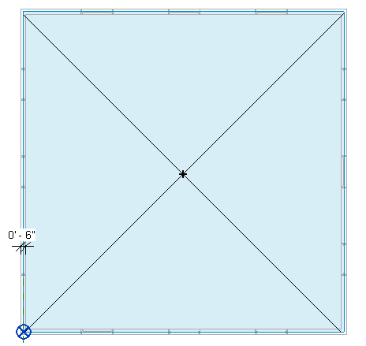

Figure : Test case 2 Level 1 Schematic Plan. The uniform wall thickness (6”) is shown.

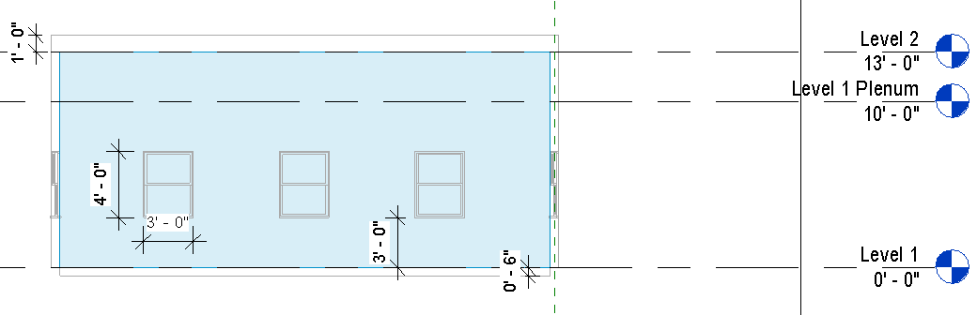

Figure : Section cut of Test 2 Geometry showing the space and wall heights, floor and ceiling thickness, and the proportions and sill height of the windows.

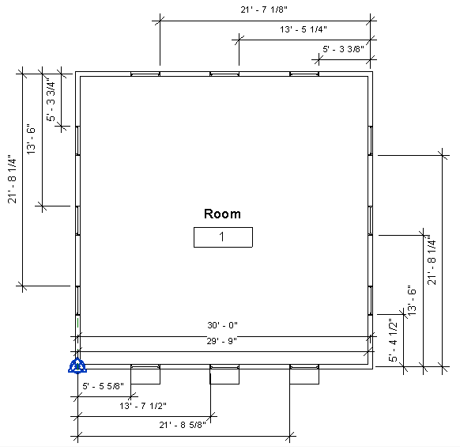

Window (typ.)

Shading device

Figure : The distances from the project or local surface origin for each geometric object.

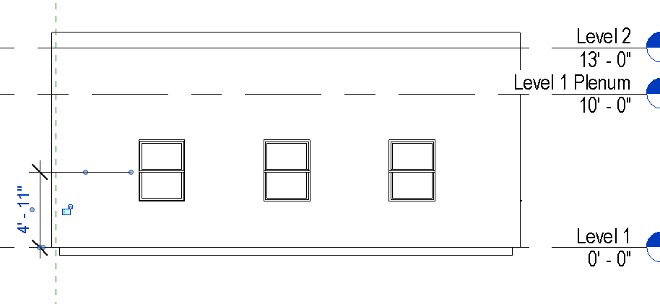

Figure : Showing the location of the 1" thick overhang relative to Z=0'

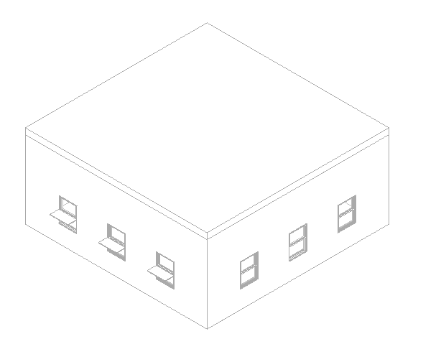

Figure : 3D axonometric view showing the shading devices on the southern exposure.

|  |  |  |  |
| --- | --- | --- | --- |
| Surface Description | Surface Thickness | Construction Type | Comments |
| Exterior Wall | 6” | n/a |  |
| Roof | 12” | n/a |  |
| Slab on Grade | 6” | n/a |  |
| Shading Device | 1” | n/a |  |

Table 1: Dimensions and descriptions of surface elements in Test Case 2.

*Example of the gbXML Code Relevant to this Example*

Relevant for this test is the definition of the <Opening> elements on the south exposure of the test file in the gbXML file. Openings will need to be broken down and properly represented geometrically in relationship to the shading device where appropriate.

*Incorrect gbXML representation of a typical window and shading device element:*

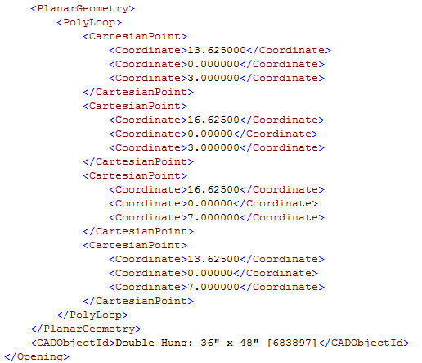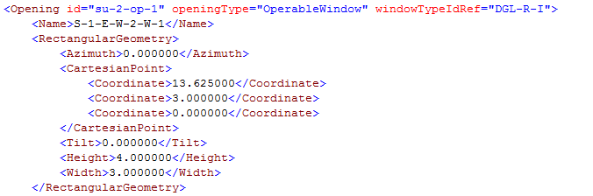

Code Snippet 1: Example description of a Southern facing window opening from the Standard File.

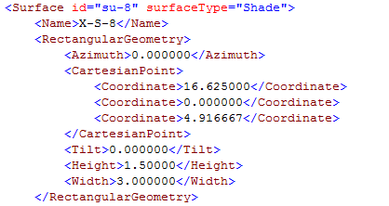

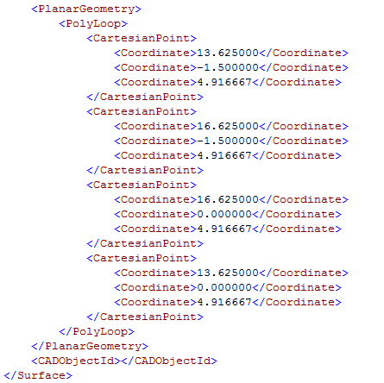

The correct representation will have the same shading device but two Opening descriptions:

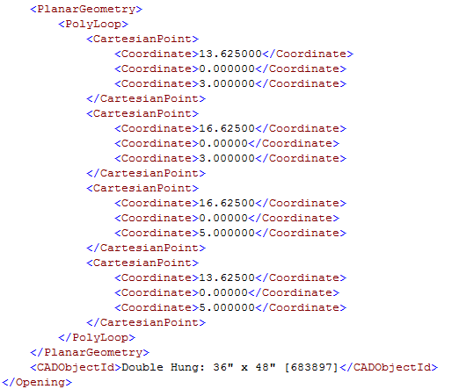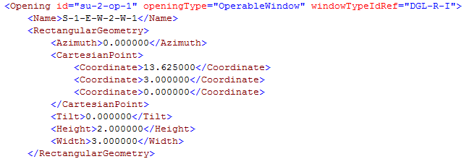

Code Snippet 2: Revised opening description for the window that is below the Shade. The differences are highlighted.

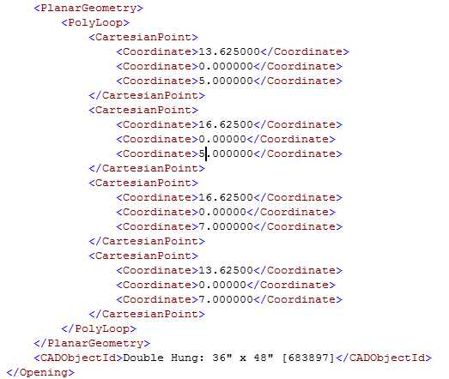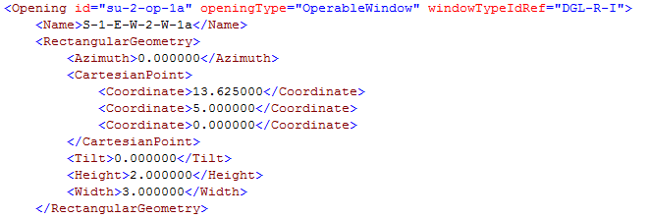

Code Snippet : Revised opening description for the window that is above the Shade. The differences have been highlighted.